AN INVESTIGATION OF FAILURE SOLVING

ISSN 2303-0992

ISSN online 2621-3176

**Matematika dan Pembelajaran**

Volume 7, No. 2, Desember 2020, h. 1-...

ILL-STRUCTURED PROBLEMS: A CASE STUDY

**Ninik Mutianingsih1, Lydia Lia Prayitno2, Eko Sugandi3, Sri Rahmawati Fitriatien4, Agus Prasetyo Kurniawan5**

*1,2,3,4Mathematics Education, Faculty of Teacher Training and Science,*

*Universitas PGRI Adi Buana Surabaya*

*5Mathematics Education, Faculty of Tarbiyah and Teacher Training,*

*Universitas Islam Negeri Sunan Ampel Surabaya*

[*1ninikmutia@unipasby.ac.id*](mailto:1ninikmutia@unipasby.ac.id)

**Abstrak**

63 siswa terlibat dalam penelitian ini dan dipilih Rizka sebagai subjek penelitian. Penelitian ini merupakan studi kasus yang bertujuan menggambarkan penyebab kegagalan Rizka dalam menyelesaikan masalah tidak terstruktur tentang persegi panjang. Hasil penelitian menunjukkan bahwa subjek mampu merepresentasikan masalah dengan bahasa sendiri. Tetapi, Rizka gagal membangun solusi yang sesuai dengan masalah karena penguasaan parsial tentang konsep persegi panjang. Rizka menggunakan *trial and error* karena gagal mengaitkan masalah dengan konsep persegi yang merupakan kunci keberhasilan pemecahan masalah. Rizka sukses dalam proses pembuktian karena proses penghitungannya tanpa memberi makna. Sementara itu, proses pemantauan dan evaluasi gagal melakukan Rizka. Kebingungan Rizka menentukan solusi akhir karena solusi yang dibangun tidak memenuhi syarat sebagai solusi. Di sinilah Rizka gagal memberikan solusi akhir. Dalam hal ini, guru memiliki peran untuk mengajar siswa untuk membangun hubungan antar konsep yang dapat digunakan dalam pemecahan masalah.

**Kata kunci:** Persegi panjang, konsep, kegagalan.

**Abstract**

63 students were involved in the study and elected Rizka as the subject of research. This is a case study aimed at describing the cause of Rizka's failure in solving ill-structured problems about the rectangle. The results showed that the subject was able to represent the problem with own language. Rizka failed to build a solution that corresponds to the problem due to partial mastery of the rectangular concept. Rizka uses trial and error because it fails to associate a problem with a square concept that is the key to problem-solving success. Rizka success in the justification process because the process is counting without giving meaning. Meanwhile, the monitoring and evaluation process carried out by Rizka has failed. Rizka confusion determines the final solution because the solution is built does not qualify the problem solution. This is where the Rizka fails to provide the final solution. In this case, teachers have a role to teach their students to build relationships between concepts that can be utilized in problem-solving.

**Keywords**: Rectangle, concept, failure.

**Citation:** Ninik Mutianingsih, Lydia Lia Prayitno, Eko Sugandi, Sri Rahmawati Fitriatien, Agus Prasetyo Kurniawan. 2020. An Investigation of Failure Solving III-Structured Problems: A Case Study. *Matematika dan Pembelajaran*, 7(2), 201-214.

DOI: <http://dx.doi.org/10.33477/mp.v6i2>

**INTRODUCTION**

An important point of education is to teach someone to think of being a reliable problem solver (NCTM, 2000; Shin, Jonassen, & McGee, 2003). Problem-solving is a complex activity be compared only to operating a component of the problem to get the solution. In the problem-solving involves cognitive components such as information statements from the problems (facts), concepts, rules, and principles (D. H. Jonassen, 1997).

Problem-solving is a process that illustrates the interaction from the ground up and from top to bottom involving the structure of knowledge that students already have started at the first time reading the problem text (Adanan, Adanan, & Herawan, 2020; Pape, 2004). Through the problem-solving process, the problem solver is directed towards determining the solution to the problem involving the knowledge it has. In fact, Mathematics classes provide the most consistent use of well-structured problems, which in line with problems in an everyday situation are involved many problems such as ill-structured (N. S. Hong, 1998). Ill-structured problems are a problem that comes from a problem situation in a particular context where more aspects of the problem situations are not described specifically, the description of the problem presented is also unclear, or the information not presented on the statement of the problem.

Furthermore, Hong (N. S. Hong, 1998) explained that students should dominate problem-solving skills in various types of problems, such as well-structured problems or ill-structured problems. When the problem solver is faced with ill-structured problems, the first step is to determine a problem in this problem’s paper (D. H. Jonassen, 1997). This is because the problem in ill-structured problems allow to be presented explicit or concealed (D. H. Jonassen, 1997; Shin et al., 2003).

The first step that the problem solver can do is to specify important information or keywords from the context of the problem presented. Furthermore, the problem solver can build a representation according to the context of the problem situation (Avdiji, Elikan, Missonier, & Pigneur, 2018). From the representation, the problem solver is required to build justification or arguments that support the solution. This is because ill-structured problems allow considerable solutions, considerable path or considerable criteria for evaluating the solution (Avdiji et al., 2018; Ge & Land, 2003). If the resulting solution does not match the problem situation then the problem solver will have to represent the problem to find an alternate solution then retest it until it finds the solution that it felt is appropriate.

The stages of solving ill-structured problems are certainly different from the solving stages of well-structured problems. Obviously, this is influenced by the characteristics of different problems between the two. (N. S. Hong, 1998; D. H. Jonassen, 1997; Shin et al., 2003) It explains the stages of solving ill-structured problems consisting of (a) representation the problem, (b) generating solution, (c) justification, and (d) monitoring and evaluation. So in this study, researchers use the problem-solving stages as above.

In some studies, such as (N. S. Hong, 1998; D. Jonassen, 2003; D. H. Jonassen, 1997; Shin et al., 2003) students were given problems to be solved. These students tried to use problem-solving strategies, organized information, understanding the situation, evaluated and tested alternatives to see possible solutions to the problem. Problem-solving is required to be involved in the complexity of the problem situation, authentic, and open (Lizunkov, Politsinskaya, Gazin, & Oblast, 2020). Of course, this is can be enhancing the level of students' mathematical thinking and problem-solving skills in an everyday situations (Chi & Glaser, 1985; Subanji & Nusantara, 2016; Sukoriyanto, Nusantara, Subanji, & Chandra, 2016).

Studies on solving ill-structured problems as in astronomy simulations conducted by (Shin et al., 2003); in learning process by (Avdiji et al., 2018; J. Hong & Kim, 2016; D. H. Jonassen, 1997); Multimedia simulations (N. S. Hong, 1998), Problem-solving skills by (Chi & Glaser, 1985; D. Jonassen, 2003; Role et al., 2016). Out of some of these studies, there has been no research discussing the failure of solver problems in solving ill-structured problems. So, this study is important to know the cause of Rizka fails when solving problems, especially on ill-structured problems about rectangular problem. In addition, it is important for teachers to look for solutions to overcome the failures that students experience so that their problem-solving skills are good. In addition, teachers must also adapt the learning process with their students' ability to overcome the failures experienced.

**METHOD**

This research aims to investigate and describe cause the students' failure in solving ill-structured problems, especially on the rectangular problem. This is a case study that underlines depth investigation, process, the activity of individuals or groups to achieve the goals (Merriam, 2009; Miles & Huberman, 1994).

Participant

63 high school students 11thgrade in Surabaya, East Java were participated in this research. The subject selection is based on students' answers, mathematical ability, and communication skills.

Materials

Students were given 45 minutes to solve ill-structured problems about the rectangle. The problem is given to students as follows.

*"You are required to ask for a minimum of two proposals to change the length and width of a rectangle (in the percentages) so that the extent increases maximally but the perimeter is less than or equal to the perimeter of the initial rectangle. What do you think would be the maximum area according to the above conditions?”*

Semi-structured interview guidelines used researchers to discover of subject failure in solving ill-structured problems. Observation is used to collect students' mathematical skills data in 10th grade.

Procedure

Researchers collected students' mathematical ability data on the rectangular studied in 10th grade. Before the study was conducted, researchers observed the mathematical learning process in the classroom to obtain information on the communication ability and mathematical skills of students. Students are given 45 minutes to submit proposals’ changes to find problems’ solutions. From the students' answers, researchers sort out the right and wrong answers. Then from the wrong answer, the researcher determines Rizka as the subject of research. The consideration of choosing Rizka is that it fails to provide a final answer, has moderate mathematics, and good communication skills.

Data Analysis

Data analysis conducted researchers through four phases, (a) classify student answers based on right and wrong answers; (b) Based on the answer incorrectly selected one random subject with moderate mathematics capable and able to communicate well for interviews. The subject is Rizka; (c) Present data to identify the cause of Rizka's failure in solving the problem, and; (d) conclude. The failure indicators in solving ill-structured problems are based on table 1.

1. Failure indicators in solving ill-structure problems

| **Phase** | **Indicator** | |
| --- | --- | --- |
| Problem representation | Failed explain the problem with own language  Failed to determine keywords  Failed to interpret keywords | |
| Generating solution | Failed to generate solution | |
| Justification | Failed to provide proof of counting and argument  Failed to use keywords in providing evidence and arguments | |
| Monitoring & evaluation | Failed explain the results of solution evaluation and conformity |

**RESULT AND DISCUSSION**

Rizka is a 16-year-old high school student of 11th grade sains from Surabaya, East Java. Rizka has moderate mathematical abilities and can communicate well. The following describes the results of Rizka's work and the research interviews with the subject based on the problem solving stage about rectangular problems.

1. **Problem Representation**

Rizka begins to read the problem presented vocally, then describes the rectangle as a form of interpretation of the problem it reads. The subject presents a picture of a rectangle as in Figure 1.

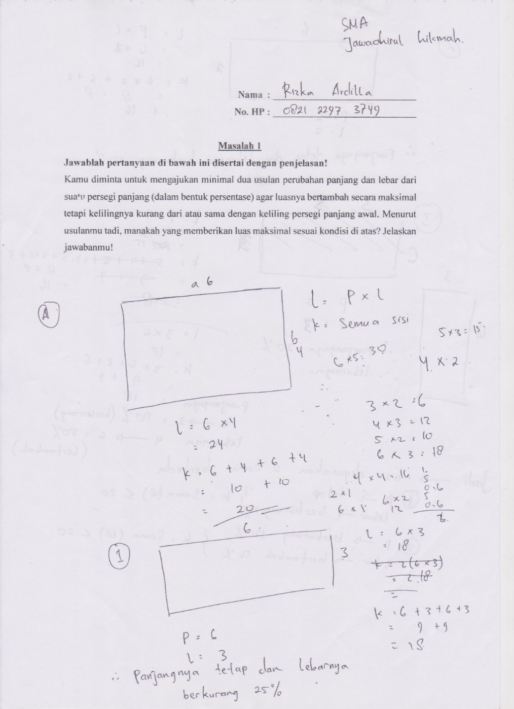

1. Interpreting problems

From the activity, Rizka shows the subject is able to represent the problem of using his own language. In this case, Rizka uses an image representation that is a rectangular image with a long symbolized by *a* and the width symbolized by *b*.

To discover other keywords from the given problem, researchers conduct interviews like the following interview.

|  |  |  |
| --- | --- | --- |
| *Q* | *:* | *Where are the important words of the problem?* |
| *Ri* | *:* | *(Subject re-read the problem given)*  *I think it is important rectangular instead of waking the space, the rectangle here two dimensions and this change in length and width, eehh...the extent of increasing maximum, and its circumference is less than or equal to* |
| *Q* | *:* | *Means how many keywords?* |
| *Ri* | *:* | *Hhhhm... The first length and width (the subject underlined the given problem), the rectangle, the area, and perimeter. It means there are four keywords.* |

The above interview, shows that Rizka assign four keywords that need to get noticed in the problem-solving process. These four keywords are (a) the length and width changes, (b) rectangles, (c) The extent of increasing maximum, and (d) the perimeter is less than or equal to. To emphasize what Rizka is expressed is a keyword, Rizka outlined it on the problem sheet as in Figure 2 below.

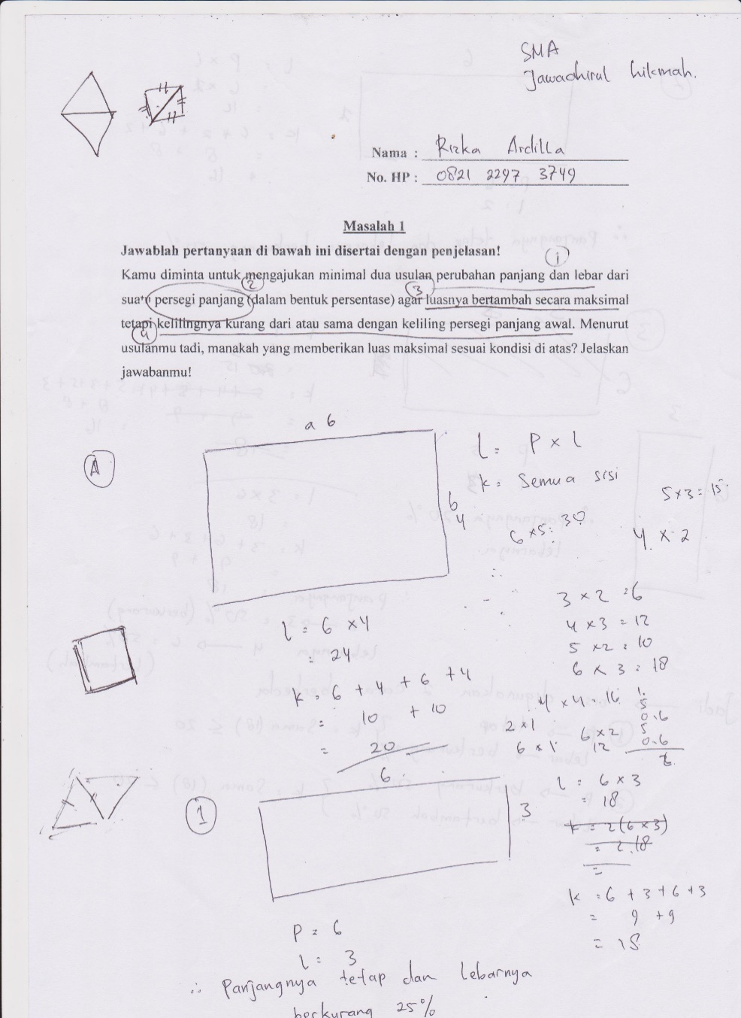

1. Underlining keywords

The next step is to interpret the specified keywords.

***1st Keyword: Change length and width***

Researchers interviewed Rizka to discover its meaning as in the following quotation.

|  |  |  |
| --- | --- | --- |
| *Q* | *:* | *What is the change in length and width?* |
| *Ri* | *:* | *Makes the length equally not the same as the initial but increased size* |
| *Q* | *:* | *Does it means?* |
| *Ri* | *:* | *Yes can be less or longer, so is the width or still can then be the percentage.* |

From the interview above, Rizka has a change in the length and width of the rectangle as it makes the length and width different from the initial conditions. After further searching, Rizka explains making different lengths and widths mean that new lengths can be less than initial lengths, new lengths can be increased from initial lengths, and new lengths are equal to initial lengths. This applies also to the new width of the rectangle.

***2nd Keyword: Rectangle***

Rizka's usage of the rectangular concept is presented in the following interview quotations.

|  |  |  |
| --- | --- | --- |
| *P* | *:* | *What kind of rectangle?* |
| *Ri* | *:* | *This is a rectangle (show to the picture on the answer sheet)*  *It.... (silence) to keep it hard to explain mam...* |
| *P* | *:* | *Tell me what you know?* |
| *Ri* | *:* | *Rectangular it in dimension two*  *hhmm…two-dimentional figure mam...* |
| *P* | *:* | *Then... What is the special characteristic of rectangular?* |
| *Ri* | *:* | *Has two equal sides, two parallel sides and two equal sides*  *Then, the same angle is also 90 degrees (pointing at the angle of the rectangle on the image)..* |

From the interview above, shows that Rizka is able to explain the general characteristics of the rectangle, is in the second dimension, has two sides equal length and large angle of 90 degrees. Rizka does not explain more detailed rectangles about folding symmetry, rotational symmetry, axis of symmetry, diagonals, and angles formed by the double diagonally intersect. When traced more about rectangular and square relationships, Rizka is experiencing confusion and is unable to explain. This is because Rizka only patlies on the sides of the rectangle without identifying other special traits. Rizka reveals that during the learning process it receives, teachers rarely associate square and rectangular concepts.

To show the length concept of the rectangle, Rizka using the symbol *a* and width using the symbol *b*. Rizka raises the idea of using a certain number as the length and width of the rectangle as a substitute *a* and *b* as in Figure 1.

***3th Keyword: Increasing maximum area***

Rizka's to interpret the increasing the maximum area presented in the following quotation.

|  |  |  |  |
| --- | --- | --- | --- |
| *P* | *:* | *The meaning increasing maximuma area?* |  |
| *Ri* | *:* | *I don’t know mam…*  *(Long silence and seem anxious)* |  |
| *P* | *:* | *Just look at your answer?* |  |
| *Ri* | *:* | *(See the answer) should be a new area increase mam. The new area should be more than 24 mam.* |  |

From the interview above, Rizka has confusion to explain the keyword's extent to increase the maximum. Rizka was silent on explaining the researchers about the keyword and seemed anxious if the answers were given wrong. When the researcher pointed to the answer, Rizka's confusion was slightly reduced, and Rizka was able to explain the significance of the increase as the formation of a new area of more than 24. So the extent of increasing to the maximum means the extent increased from the initial area and increase as much as possible.

***4th Keyword: The perimeter is less than or equal to***

The meaning of Rizka to the perimeter is less than or equal to the quote presented in the following interview.

|  |  |  |
| --- | --- | --- |
| *P* | *:* | *Meaning the perimeter is less than or equal to, should it be?* |
| *Ri* | *:* | *My proposal, the perimeter is less than or equal to and not more* |
| *P* | *:* | *Meaning?* |
| *Ri* | *:* | *No more than the initial perimeter 20* |

With the previous usage, Rizka gives the meaning that the new perimeter of the rectangle should be no more than 20. Rizka no longer experienced confusion in the cause because it has had previous experience in the increase in the maximum.

1. **Generating Solution**

In generating the solution, Rizka uses the number 6 as its length and 4 as the width of the rectangle. The reason Rizka uses that number as a substitute for length and width as it likes the number. This indicates that Rizka will do trial and error on the length and width of the rectangle so that it meets the specified perimeter requirements.

The first proposal, Rizka proposes a length of 6 and a width of 3 then determines its percentage as in Figure 3 below.

|  |  |
| --- | --- |
| C:\Users\Lidya_PC\Desktop\3rd SCOPUS JOURNAL\Hasil 2\Subjek 1 001.jpg | Translate:  *p =* length = 6  *l* = width = 3  Fixed length and width reduced by 25% |

1. First proposal

While in the second proposal, Rizka proposes a length of 6 and a width of 2 and then determines its percentage as in Figure 4.

|  |  |
| --- | --- |
| C:\Users\Lidya_PC\Desktop\3rd SCOPUS JOURNAL\Hasil 2\Subjek 1.2 001.jpg  C:\Users\Lidya_PC\Desktop\3rd SCOPUS JOURNAL\Hasil 2\Subjek 1.2 001.jpg | Translate:  *p =* length = 6  *l =* width = 2  Fixed length and width reduced by 50% |

1. Second proposal
2. **Justification**

In the next step, Rizka gives the given proposal justification by calculating the area and perimeter of the rectangle. Justification given Rizka as the following Figure 5.

|  |  |
| --- | --- |
| First proposal | C:\Users\Lidya_PC\Desktop\3rd SCOPUS JOURNAL\Hasil 2\Subjek 1 001.jpg |
| Second proposal | C:\Users\Lidya_PC\Desktop\3rd SCOPUS JOURNAL\Hasil 2\Subjek 1.2 001.jpg |

1. Rizka's justification of the proposal

Each proposed proposal, Rizka begins by specifying the area of the rectangle followed by a perimeter.

1. **Monitoring and Evaluation**

Rizka monitors and evaluates its propose based on its justification. The results of Rizka's work in monitoring and evaluation in the following Figure 6.

|  |  |
| --- | --- |
| C:\Users\Lidya_PC\Desktop\3rd SCOPUS JOURNAL\Hasil 2\Subjek 1.2 001.jpg | Translate:  So, we can use two methods   1. Length – fixed   Width reduced by 25%   1. Length reduced by 50%   Width increased by 50% |

1. Monitoring and evaluation

To explore the understanding of the subject in concluding the results of monitoring and evaluation, researchers interviewed Rizka like the following interview.

|  |  |  |
| --- | --- | --- |
| P | : | *So what is your conclusion?* |
| Ri | : | *In my proposal, my perimeter is less than or equal to and no more* |
| P | : | *It means?* |
| Ri | : | *This proposal (appoint the first proposal)*  *Only 25% reduced and the second reduced to 50%* |
| P | : | *Are you sure?* |
| Ri | : | *If answer both mam?* |
| P | : | *Meaning?* |
| Ri | : | *Can be used two different ways* |

In the process of concluding, Rizka also experienced confusion determining the most appropriate proposal to answer the problem. Rizka interprets that every problem given should have a solution so that Rizka concludes two ways that can be used as a solution.

**DISCUSSION**

Rizka's ability to represent problems with his own language is the first step in the problem-solving process. This is because the problem representation is supposed to be making sense for the problem solver so it supports the problem solving process done (Hoogland, de Koning, Bakker, Pepin, & Gravemeijer, 2018; Hoogland & Pepin, 2016), (Adanan et al., 2020). A problem representation is a key component in the problem-solving process that helps students (Avdiji et al., 2018; Bal, 2014; Boonen, Reed, Schoonenboom, & Jolles, 2016; Goldin, 1998; Stylianou & Silver, 2004; Xin, Jitendra, & Buchman, 2005). The researcher agreed that the problem representation is a key component in solving mathematical problems, especially verbal problems whose involves representations, both symbolically and visually.

The determination of the keywords that Rizka set helped him to represent the problem. Keywords are a form of understanding of the subject to the problems presented (Adanan et al., 2020; Hegarty, Mayer, & Monk, 1995; Stylianou & Silver, 2004). The emphasis of the subject by underlining is one of the learning strategies of a repeating strategy. Arends reveals through an underlined process giving students the opportunity to connect new information to problems with existing knowledge. In this case, enhancing creative thinking skill is the one important component in problem solving (Palupi, Subiyantoro, Triyanto, & Rukayah, 2020). The steps students performed to represent the problem with attention to information relevant to the problem and present problems in concrete objects (Mairing, 2017; Xin et al., 2005). In this case, Rizka used using a drawing picture.

There are many ways for students to solve problems, one of which raises ideas, such as length and width. Such as using numbers to declare the length and width of a rectangle (Anwar, Yuwono, As’ari, Sisworo, & Rahmawati, 2016) or use the price of a particular item (Abdillah, Nusantara, Subanji, Susanto, & Abadyo, 2016) to help solve the problem. The idea that Rizka developed is not used properly in generating solutions. This is because the solution built by Rizka is the result of trial and error which is then justification. Whereas submitting proposals is one of the right methods to solve the problem (Chi & Glaser, 1985; Debrenti, 2015) in particular in this study.

The trial and error of Rizka because the subject has no mastery of the concept of a square. In fact, mastery of concept is a key in problem solving process. Students who have good concept mastery are able to connect between concepts that have been studied with problems that will be solved (Anwar et al., 2016; Subanji & Nusantara, 2016). Rizka's failures are the same as the research (Abdillah et al., 2016; Debrenti, 2015) which states that failure in establishing a relationship between knowledge is one of problem solving constraints (Debrenti, 2015), particularly ill-structured problems.

The justification made by Rizka in determining the perimeter and area of the rectangle is not a barrier. From the investigative outcome, Rizka knows how to calculate the perimeter and area of the rectangle but is unable to explain the meaning of those concept clearly.

Rizka fails in monitoring and evaluation of the right solution. Consequently, the final solution provided by Rizka does not match the desired situation of the problem. Self-check abilities involve self-awareness to determine the final solution of the problem solving process (Debrenti, 2015). It is reinforced (Debrenti, 2015; Ijirana & Nadjamuddin, 2019) who expressed metacognitively students can be developed through a problem solving process.

From the results of Rizka's work above, it shows that in the process of solving problems Rizka works based on alteration (Sukoriyanto et al., 2016; Swastika, Nusantara, Subanji, & Irawati, 2020). This shows that Rizka has a good self-regulated in problem solving process. But this does not guarantee that the subject is able to find the right solution (Ijirana & Nadjamuddin, 2019; Lim, Jaya, Jalil, & Saad, 2020). So, students can improve their ability to formalize and generalize understanding of problems by finding mathematical structures in problems that are appropriate to real-life contexts (Prayitno, Purwanto, Subanji, & Susiswo, 2018), then determining alternative solutions, implementing them, and finding appropriate solutions. (J. Hong & Kim, 2016; Liang, Tsai, Chang, Lin, & Su, 2016).

In the learning process it is important for teachers to associate a concept with another mathematical concept (Palupi et al., 2020) using problem-based learning (Lizunkov et al., 2020). The goal is to have students' mastery over the mathematical concept integral. In this study students were required to relate between rectangular and square concepts to find solution the problems.

**CONCLUSION**

From the results and discussion above, Rizka has failed to build solutions as well as monitoring and evaluation of proposed solutions. Based on the search results of researchers this is due to the mastery of a partial rectangular concept so that Rizka only do a trial and error in finding a solution. In fact, mastery of concept is a key in problem- solving process. Consequently the solution provided is not according to the wishes of the problem. For that, more research needs to be done by choosing a subject that has a good quadrilent concept mastery.

REFERENCES

Abdillah, Nusantara, T., Subanji, Susanto, H., & Abadyo. (2016). The Students Decision Making in Solving Discount Problem. *International Education Studies*, *9*(7), 57–63. https://doi.org/10.5539/ies.v9n7p57

Adanan, H., Adanan, M., & Herawan, T. (2020). M-WebQuest Development : Reading Comprehension of Senior High School Students in Indonesia. *International Journal of Emerging Technologies in Learning*, *15*(3), 74–92. Retrieved from https://doi.org/10.3991/ijet.v15i03.10628

Anwar, R. B., Yuwono, I., As’ari, A. R., Sisworo, & Rahmawati, D. (2016). Mathematical Representation by Students in Building Relational Understanding on Concepts of Area and Primeter of Rectangle. *Educational Research and Reviewsv*, *11*(21), 2002–2008. https://doi.org/10.5897/ERR2016.2813

Avdiji, H., Elikan, D., Missonier, S., & Pigneur, Y. (2018). Designing Tools for Collectively Solving Ill-Structured Problems. *Proceedings of the 51st Hawaii International Conference on System Sciences*, (January). https://doi.org/10.24251/hicss.2018.053

Bal, A. P. (2014). The Examination of Representations used by Classroom Teacher Candidates in Solving Mathematical Problems. *Educational Sciences: Theory & Practice*, *14*(6), 2349–2365. https://doi.org/10.12738/estp.2014.6.2189

Boonen, A. J. H., Reed, H. C., Schoonenboom, J., & Jolles, J. (2016). It’s Not a Math Lesson - We’re Learning to Draw ! Teachers’ Use of Visual Representations in Instructing Word Problem Solving in Sixth Grade of Elementary School. *Frontline Learning Research*, *4*(5), 55–82. https://doi.org/http://dx.doi.org/10.14786/flr.v4i5.245

Chi, M. T. H. H., & Glaser, R. (1985). *Problem Solving Abilities.* *Human Abilities: An Information Processing Approach*. Washington DC. Retrieved from http://eric.ed.gov/?id=ED257630%5Cnfile:///Users/jessicabartley/Downloads/ADA134717.pdf%5Cnhttp://oai.dtic.mil/oai/oai?verb=getRecord&metadataPrefix=html&identifier=ADA134717

Debrenti, E. (2015). Visual Representations in Mathematics Teaching: An Experiment with Students. *Acta Didactica Napocensia*, *8*(1), 19–26. Retrieved from eric.ed.gov

Ge, X., & Land, S. (2003). Scaffolding students’ problem solving processes in an ill-structured task using question prompts and peer interactions. *Educational Technology Research and Development*, *51*(1), 21–38. Retrieved from http://dx.doi.org/10.1007/BF02504515

Goldin, G. A. (1998). Representational systems, learning, and problem solving in mathematics. *The Journal of Mathematical Behavior*, *17*(2), 137–165. https://doi.org/10.1016/S0364-0213(99)80056-1

Hegarty, M., Mayer, R. E., & Monk, C. A. (1995). Comprehension of Arithmetic Word Problems : A Comparison of Successful and Unsuccessful Problem Solvers inconsistent problems with those of problem solvers who do. *Journal of Educational Psychology*, *87*(1), 18–32.

Hong, J., & Kim, M. (2016). Mathematical abstraction in the solving of ill-structured problems by elementary school students in Korea. *Eurasia Journal of Mathematics, Science and Technology Education*, *12*(2), 267–281. https://doi.org/10.12973/eurasia.2016.1204a

Hong, N. S. (1998). *The Relationship Between Well-Structured and Ill-Structured Problem Solving in Multimedia Simulation*. The Pennsylvania State University.

Hoogland, K., de Koning, J., Bakker, A., Pepin, B. E. U., & Gravemeijer, K. (2018). Changing representation in contextual mathematical problems from descriptive to depictive: The effect on students’ performance. *Studies in Educational Evaluation*, *58*(November 2017), 122–131. https://doi.org/10.1016/j.stueduc.2018.06.004

Hoogland, K., & Pepin, B. (2016). The Intricacies of Assessing Numeracy : Investigating Alternatives to Word Problems Kees Hoogland. *Adults Learning Mathematics: An International Journal*, *11*(2), 14–26. Retrieved from http://www/researchgate.net/publication/3132332761\_The\_Intricacies\_of\_Assessing\_Numeracy\_Incestigating\_Alternatives\_to\_Word\_Problems

Ijirana, & Nadjamuddin, L. (2019). Time series study of problem solving ability of Tadulako University students using metacognitive skill based learning model. *International Journal of Emerging Technologies in Learning*, *14*(21), 227–234. https://doi.org/10.3991/ijet.v14i21.11684

Jonassen, D. (2003). Using Cognitive Tools to Represent Problems. *Journal of Research on Technology in Education*, *35*(October2003), 37–41. https://doi.org/10.1080/15391523.2003.10782391

Jonassen, D. H. (1997). Instructional Design Models for Well-Structured and Ill-Structured Problem-Solving Learning Outcomes. *Educational Technology Research and Development*, *45*(1), 65–94. Retrieved from http://www.jstor.org/stable/30220169

Liang, C., Tsai, S., Chang, T., Lin, Y., & Su, K. (2016). A Meaning-based English Math Word Problem Solver with Understanding , Reasoning and Explanation. In *COLING 2016, the 26th International Conference on Computational Linguistic: System Demonstrations* (pp. 151–155).

Lim, C. L., Jaya, S., Jalil, H. A., & Saad, W. Z. (2020). Peer Learning, Self-Regulated Learning and Academic Achievement in Blended Learning Courses : A Structural Equation Modeling Approach. *International Journal of Emerging Technologies in Learning (IJET)*, *15*(3), 110–125.

Lizunkov, V., Politsinskaya, E., Gazin, K., & Oblast, K. (2020). The Architecture of Project-Based Learning in the Supplementary Vocational Education System in a Higher Education. *International Journal of Emerging Technologies in Learning (IJET)*, *15*(4), 227–234. Retrieved from https://doi.org/10.3991/ijet.v15i04.11694

Mairing, J. P. (2017). Thinking Process of Naive Problem Solvers to Solve Mathematical Problems. *International Education Studies*, *10*(1), 1–11. https://doi.org/10.5539/ies.v10n1p1

Merriam, S. (2009). *Qualitative Research and Case Study Aplication in Education*. San Fransisco: Jossey-Bass.

Miles, M. B., & Huberman, M. A. (1994). *Qualitative Data Analysis: A Sourcebook of New Methods*. Baverly Hills: SAGE Publications, Inc.

NCTM. (2000). *Principles and Standards for School Mathematics*. United States of America: The National Council of Teachers of Mathematics Inc. Retrieved from www.nctm.org

Palupi, B. S., Subiyantoro, S., Triyanto, T., & Rukayah, R. (2020). Creative-Thinking Skills in Explanatory Writing Skills Viewed from Learning Behaviour: A Mixed Method Case Study. *International Journal of Emerging Technologies in Learning (IJET)*, *15*(01), 200–212. https://doi.org/10.3991/ijet.v15i01.11487

Pape, S. J. (2004). Middle School Children’s Problem-Solving Behavior: A Cognitive Analysis from a Reading Comprehension Perspective. *Journal for Research in Mathematics Education*, *35*(3), 187–219.

Prayitno, L. L., Purwanto, P., Subanji, S., & Susiswo, S. (2018). Identification Errors of Problem Posed by Prospective Teachers About Fraction Based Meaning Structure. *International Journal of Insights for Mathematics Teaching*, *01*(1), 76–84. Retrieved from http://journal2.um.ac.id/index.php/ijoimt/article/viewFile/3018/1828

Role, T., Skill, F. M., Fuchs, L. S., Gilbert, J. K., Powell, S. R., Cirino, P. T., … Tolar, T. D. (2016). The Role of Cognitive Processand Calculation Accuracy and Fluency in Word-Problem The Role of Cognitive Processes , Foundational Math Skill , and Calculation Accuracy and Fluency in Word-Problem Solving Versus Prealgebraic Knowledge.

Shin, N., Jonassen, D. H., & McGee, S. (2003). Predictors of well-structured and ill-structured problem solving in an astronomy simulation. *Journal of Research in Science Teaching*, *40*(1), 6–33. https://doi.org/10.1002/tea.10058

Stylianou, D. A., & Silver, E. A. (2004). The Role of Visual Representations in Advanced Mathematical Problem Solving : An Examination of Expert- Novice Similarities and Differences. *Mathematical Thinking and Learning*, *6*(4), 353–387. Retrieved from http://sci-hub.tw/10.1207/s15327833mtl0604\_1#

Subanji, S., & Nusantara, T. (2016). Thinking Process of Pseudo Construction in Mathematics Concepts. *International Education Studies*, *9*(2), 17. https://doi.org/10.5539/ies.v9n2p17

Sukoriyanto, J., Nusantara, T., Subanji, S., & Chandra, T. D. (2016). Students ’ thinking process in solving combination problems considered from assimilation and accommodation framework. *Educational Research and Reviews*, *11*(16), 1494–1499. https://doi.org/10.5897/ERR2016.2811

Swastika, G. T., Nusantara, T., Subanji, & Irawati, S. (2020). Alteration representation in the Process of Translation Graphic to Graphic. *Humanities & Social Sciences Reviews*, *8*(1), 334–343. https://doi.org/http://doi.org/10/18510/hsr.2020.8144

Xin, Y. P., Jitendra, A. K., & Buchman, A. D. (2005). Effects of Mathematical Word Problem – Solving Instruction on Middle School Students with Learning Problems. *The Journal of Special Education*, *39*(3), 181–192.