STUDENT THINKING PROCESS IN SOLVING MATHEMATICAL PROBLEMS BASED ON APOS

Patma Sopamena, Syafrudin Kaliky, Nurlaila Sehuwaky, Kasliyanto, Fahruh Juhaevah

IAIN Ambon, Jl. Dr. H. Tarmizi Taher Kebun Cengkeh Batu Merah Atas Ambon, Indonesia
Email: patma.sopamena@iainambon.ac.id

Abstract
This study aimed to provide insights into student thinking process in solving factorization of algebraic expressions based on APOS. A qualitative-exploratory design was employed in this study, where the participants were asked to solve mathematical problems and perform think-aloud protocols. Interview was conducted to extract more interesting data and clarify the participants’ answers and logical analysis. Based on the APOS framework, there were two categories of thinking process performed by the eighth grade students from SMP Negeri 23 Ambon. The first category is complete thinking structure that was indicated by providing the correct answer to the problem. This process began with interiorization as Action, followed by coordination, encapsulation, reversal, regulation or de-encapsulation as Process towards the object. The second category or scheme is incomplete thinking structure, marked by making errors during the problem-solving process and fixing the errors after reflection. The incomplete thinking structure occurred on interiorization as Action and coordination, reversal and de-encapsulation as Process towards the object.

Keywords: Thinking process, mathematical problem solving, APOS

Abstrak
Penelitian ini bertujuan untuk memberikan gambaran tentang proses berpikir siswa dalam menyelesaikan masalah faktorisasi suku aljabar berdasarkan APOS. Tipe penelitian ini adalah kualitatif-eksploratif di mana siswa diminta untuk menjawab dan mengungkapkan secara keras apa yang dipikirkan. Selanjutnya, diadakan wawancara jika diperoleh data yang menarik dan perlu diklarifikasi dan analisis logis. Subjek penelitian Hasil penelitian menunjukkan bahwa Proses berpikir siswa kelas VIII SMP Negeri 23 Ambon dalam menyelesaikan masalah faktorisasi suku aljabar berdasarkan kerangka APOS dapat digolongkan ke dalam 2 kategori. Pertama, skema (struktur berpikir) lengkap. Ditandai dengan proses penyelesaian yang benar. Diawali dengan aksi interiorisasi kemudian proses (koordinasi, enkapsulasi, reversal, regulasi (de-enkapsulasi) terhadap objek ketika penyelesaian dan benar. Kedua, skema (struktur berpikir) tidak lengkap. Ditandai dengan kesalahan yang terjadi ketika proses penyelesaian masalah namun setelah refleksi jawaban menjadi benar. Ketidaklengkapan subtruktur berpikir terjadi pada aksi interiorisasi dan proses (koordinasi, reversal, dan de-enkapsulasi) terhadap objek.

Kata kunci: Proses berpikir, penyelesaian masalah matematika, APOS

Mathematics learning is an activity that requires a thinking process. A person who thinks is doing mental activities. People who learn math perform mental activities through problem solving. However, mathematics learning in Indonesia often puts an emphasis on memorizing concepts. This certainly has a significant effect on the students’ thinking process. Based on the TIMSS four-year survey in 2015, mathematical abilities of Indonesian students ranked 45 out of 51 participating countries (Reddy et al., 2016: 21). Meanwhile, a three-year study conducted by PISA in 2015 showed that Indonesian students scored among the lowest (62 out of 70 countries) in mathematics (OECD, 2019). Therefore, mathematics research needs to focus more on students’ thinking processes and development of math problems based on PISA and TIMSS problems, as has been researched by (Ahyan, Zulkardi, & Darmawijoyo, 2014); (Oktiningrum, Zulkardi, & Hartono, 2016); (Noviarsyh Dasaprawira, Zulkardi, & Susanti, 2019). Vincent Ruggiero defines thinking as "a mental activity carried out to solve a problem, make a decision and fulfill curiosity in understanding a problem" (Sopamena, 2017). Thinking process can only be recognized when a person takes action through problem solving. Ed Dubinsky in his research on the construction process of "genetic decomposition" suggests that one’s actions in solving mathematical problems can be seen from interiorization and encapsulation, hereinafter referred to as APOS (Action, Process, Object, and Schema) (Dubinsky, 2014); (Arnon et al., 2014). This study employed APOS approach to describe students’ thinking process in solving factorization of algebraic terms.
Until the present, studies on the application of APOS approach have only focused on two aspects. There are various studies that examine learning by applying the APOS framework (Salgado & Trigueros, 2015); (Borji, Alamolhodaei, & Radmehr, 2018); (Arnawa, Yerizon, & Nita, 2019); (Arnawa, Yerizon, Nita, & Putra, 2019); (Afgani, Suryadi, & Dahlan, 2019). In addition, a number of research has been carried out to assess students’ mathematical abilities and understanding using the APOS framework (Tziritas, 2011); (Maharaj, 2013); (Mena-Lorca & Parraguez, 2016); (Bansilal, Brijlall, & Trigueros, 2017); (Afgani, Suryadi, & Dahlan, 2017); (Hidayatullah, 2019). Salgado & Trigueros point out that by using an activity model designed from genetic decomposition, although a lot of literature and teachers say it is difficult, at least three students from the researched group succeeded in demonstrating the construction of eigenvalues and the concept of eigenvectors. Furthermore, Bansilal, Brijlall, & Trigueros suggest that the best way to help students develop positive attitudes towards mathematics is to facilitate their understanding of mathematics. From these two aspects, there has been no specific study looking at how students think in solving mathematical problems using the APOS framework.
Many themes have been discussed in past studies related to the APOS framework, including: the APOS framework itself (Dubinsky & Mcdonald, 2005); (Cetin & Dubinsky, 2017), genetic decomposition (Dubinsky, 1991), APOS learning and mathematical understanding according to the APOS framework (Asiala et al., 1996).
Piaget explains that in solving a mathematical problem, an individual always goes through a reflective abstraction construction process that is exemplified in logical-mathematical thinking at an early age (Dubinsky, 1991). The construction processes of reflective abstraction include: interiorization, coordination, encapsulation, generalization and reversal construction (Dubinsky). The main mental mechanisms in building mental structures of action, processes, objects and schemes are called interiorization and encapsulation (Dubinsky, 2014); (Arnon et al., 2013). Action is a transformation of reactions to stimuli that are felt by individuals externally (Asiala et al., 1996); (Bansilal, 2014); (Dubinsky & Mcdonald, 2005). Process is a mental structure in carrying out the same operations as action, but entirely occurs in the individual mind (interiorization occurs) (Dubinsky & Mcdonald, 2005); (Bansilal, 2014); (Asiala et al., 1996). Object is the totality of transformation consciousness encapsulated into cognitive objects (Arnon et al., 2014); (Dubinsky, 2014); (Arnon et al., 2013).
Furthermore, this reflective abstraction is transformed into mental object construction and mental action, hereinafter referred to as Scheme (Dubinsky, 2002: 101). Piaget (1952, p. 7) defines Scheme as components of cohesive, repetitive action that have components of action that are closely related and governed by core meanings. Scheme is a collection of objects and processes that are more or less coherent (Dubinsky, 2002: 101). Mathematical topics often involve many actions, processes, and objects that need to be organized and linked into a coherent framework, called a Scheme (Arnon et al., 2014). Thus, a Schema is a structured group of concepts than can be used to represent objects, scenarios or sequences of events or relationships.
Therefore, this study aimed to describe students’ thinking process in solving mathematical problems based on the APOS framework. The framework used in this study referred to the genetic decomposition process.

METHODS
This study was conducted in SMP N 23 Ambon, a public junior high school in Ambon. There are 13 teachers and 3 study groups that could potentially participate in this study. This study attempted to reveal the occurrence of students' thinking processes in solving mathematical problems. In this study, the participants were asked to solve problems by expressing aloud what they were thinking (Think Aloud protocols). The participants' thinking processes were then assessed based on the APOS framework (Action, Process, Object and Scheme). The data were collected in the form of verbal data, so this study was categorized as a qualitative-exploratory study.
The selection of the study participants was based on the students' ability to solve problems instinctively. This article describes the problem solving process of a subject who provided a perfect or correct answer (S1) and from a subject who provided a wrong answer, but was then given the opportunity to reflect on his answer so that he could correct his answer (S2). The mathematical problem administered to the students was factorization of algebraic terms.
The data of this study were collected to describe the participants’ thinking process in solving representative mathematical problems based on the APOS framework. The stages of data collection consisted of the following activities:
- A direct observation was conducted while the participants were completing the task.
- The participants or the subjects were assigned to solve a problem on factorization of algebraic expressions and asked them to verbally express what they were thinking during the problem-solving process.
- The participants’ verbal expressions were recorded
- Interview was done to explore what the participants were thinking during the problem-solving process.
The verbal and written data were analyzed for consistency. A clarification interview was conducted if there were inconsistent data. The clarification interview was conducted by re-interviewing the participants. If the data remained inconsistent, they would be omitted from the analysis.
Data analysis was performed in several stages that included: (1) transcribing the verbal data, (2) examining all available data from various sources, namely the think aloud data, the results of the interviews, the results of the observations that had been written in the field notes, and the results of student concept construction, (3) reducing the data set obtained based on the APOS framework by making a core summary, process, and statements that need to be kept in it, (4) compiling data in units and categorizing them by coding, (5) describing the students thinking structure in solving the problem on factorization of algebraic expressions based on APOS, (6) analyzing the students’ thinking process based on APOS, (7) analyzing interesting phenomena and (7) drawing conclusions (Creswell, 2012: 238-241).

RESULTS AND DISCUSSION
- Analysis of the S1 and S2 Thinking Process based on the APOS Framework
Subject 1 (S1) demonstrated a complete cognitive structure and met the criteria of the APOS framework when solving the factorization of algebraic expression task. This means that in the problem solving process, S1 carried out a complete thinking process. S1 immediately did a reflection by questioning his problem-solving result. Furthermore, the reflection result was also true. On the other hand, in completing the task, S2 showed an incomplete cognitive structure and a disconnected substructure, but the process still met the criteria of the APOS framework. In addition, it can also be concluded that S2 made a mistake in the process of completing the task. However, after being given the opportunity to reflect, he replaced his answer with the correct answer. This means that there are students who have a complete thinking structure marked by a correct problem-solving process and there are students who have an incomplete thinking structure (the problem solving process is wrong but after doing a reflection, the answer is correct). This finding corroborates with those of Subanji (Subanji & Nusantara, 2016). The S1 and S2 thinking processes are described in detail as follows.
- S1 Thinking Structure
When S1 was asked to solve an essay question, he could understand the problem and provide the right solution. Then, S1 was given the opportunity to reflect on the test question. The results of the S1 reflection were also proven correct, so the answers obtained from before and after the reflection were basically the same, namely the correct answer. S1 thinking structure can be seen in Diagram 1 and Diagram 2.
Diagram 2 shows that S1 has constructed a complete thinking scheme, suggesting that there was no error done during his thinking process. The answer provided by S1 before and after the reflection was correct.
- S2 Thinking Process
When S2 was asked to solve the task, the first thing that S2 did was to read the question, then explain the purpose of the question, and solve the question immediately. Similar to S1, S2 was also given the opportunity to reflect on the answer. After reflection, S2 realized that he had made a mistake and thus he made an attempt to correct the answer. The S2 thinking structure can be seen in Diagram 3 and Diagram 4.

The diagram above shows that S2 reconstructed his thinking scheme when he detected an error in it and quickly accommodated his thinking scheme. S2’s thinking scheme accommodation occurred when S2 took the child’s age into account. It was at this stage that S2 made a mistake. Furthermore, the accommodation of S2 thinking scheme also occurred when S2 used the properties of operations to solve the algebraic term operations. S2 made a mistake in the process of adding a certain number. After being given the opportunity to reflect, S2 was able to correct the error and obtain the correct answer.

- Analysis on S1 and S2 Problem-Solving Processes based on the APOS Framework

- S1 Thinking Process in Solving a Problem on Factorization of Algebraic Expressions based on the APOS Framework
S1 demonstrated a complete thinking structure when solving a problem in the form of an essay test on factorization of algebraic terms. This was marked by the absence of errors in the problem solving process before and after reflection. S1 thinking process can be seen as in Figure 1.
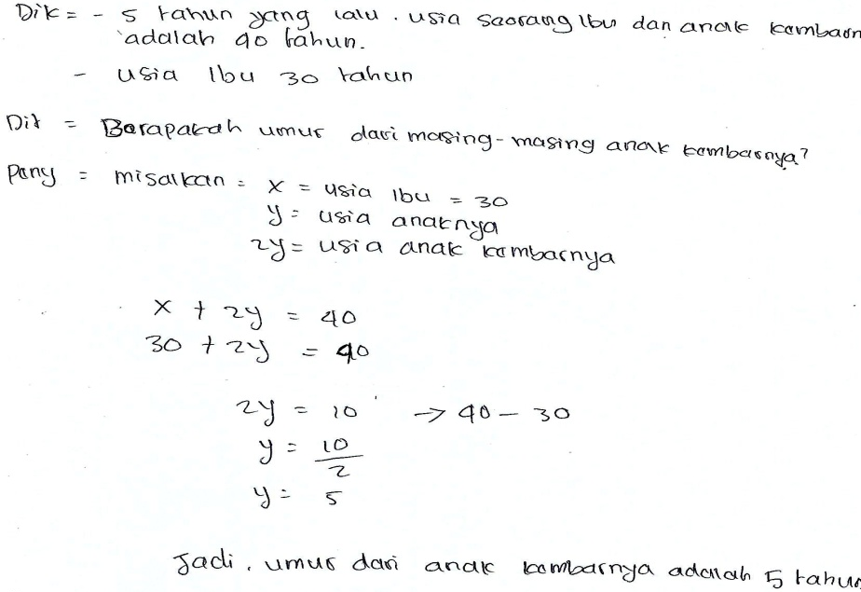
Figure 1. S1’s Answer before and after Reflection
In completing the task, S1’s thinking process began with contemplating the problem (interiorization) by determining what is known and what is asked on the test. Next, S1 translated the problem in his mind and put it onto the answer sheet. This explains that at this stage, S1 did Action. This finding is also reinforced by the S1’s statement during the interview, as shown below.:
P : Do you understand the problem?
S1 : Yes I do. It is explained that five years ago, the total age of mother and her twin daughters was 40, given the fact that the age of mother was 30 years. I was asked to determine the age of each twin individual.
Then, S1 assumed that x was the age of mother, which is 30 years old and y was the age of each twin individual and 2y was the total age of the twins. What S1 did suggests that he performed encapsulation that is a mental transformation from Process to Object. In other words, S1 was doing Process.
Finally, S1 obtained the equation x + 2y = 40, indicating that he had done generalization or de-encapsulation (Action and Process). In addition, S1 substituted x into the equation 30 + 2y = 40 and did interiorization as Action. Then, S1 performed a mental construction from coordination construction Process and reversal towards the equation by applying the algebraic operation property, which is 2y = 40 – 30. Then, S1 did encapsulation as Process, that is 2y = 10 followed by y = and y = 5. Therefore, S1 was doing Object.
The final stage of S1’s thinking process was drawing a conclusion and doing a reflection. S1 did the reflection consciously without being asked. However, he found no error and thus was convinced about the answer. S1 produced Object from Action and Process and organized the Object into a Scheme. It thus suggests that at this stage, S1 performed Scheme (Sopamena, Nusantara, Irawan, & Sisworo, 2016). This means that the students successfully carried out the completion process using the characteristics of APOS, as stated in (Syamsuri, Purwanto, Subanji, & Irawati, 2017).
- S2 Thinking Process in Solving a Problem on Factorization of Algebraic Expressions based on the APOS Framework

Subject 2 (S2) showed an incomplete thinking structure based on the APOS framework in solving the factorization of algebraic expression task. The incomplete thinking structure was marked by an error made by the subject during the problem-solving process. Then, S2 did a reflection and finally could provide the correct answer and perform thinking process that meets the criteria of APOS. The S2’s answer to the problem can be seen in Figure 2.
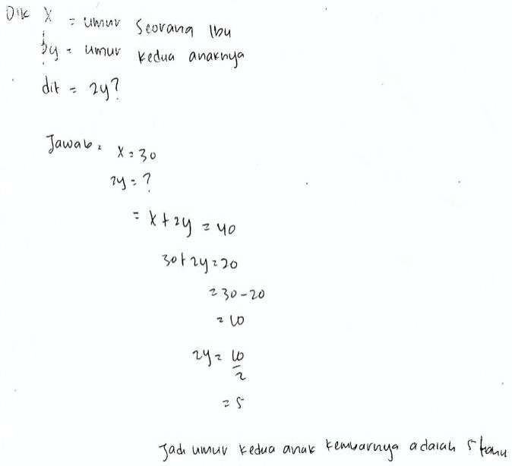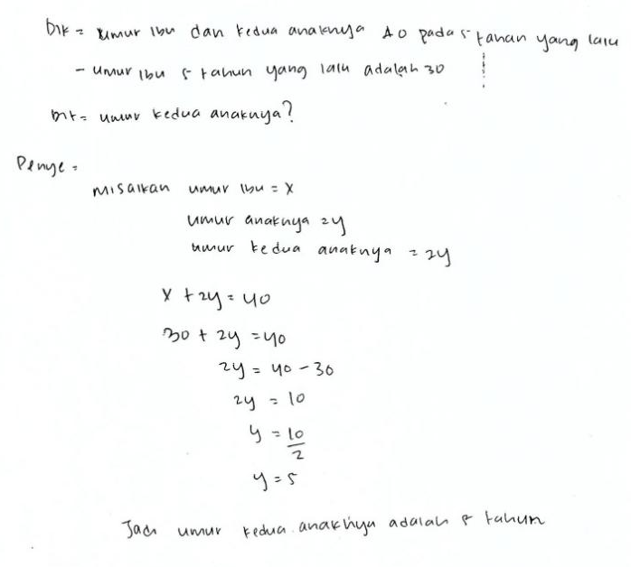
Figure 2. S2’s Answer before Reflection Figure 3. S2’s Answer after Reflection
S2 began the problem-solving process with interiorization and association by writing down what is known from the question. The error made by S2 was to assume x as the age of mother and 2y as the age of the twin daughters.
Then, S2 did encapsulation that is a mental transformation from Process to Object, meaning that S2 performed Process. This finding is also supported by S2’s statement as follows.
P : Can you tell me what is being asked in the problem?
S2: The question is to figure out the age of each twin individual.
Based on his understanding, S2 obtained the equation x + 2y = 40. It means that S2 performed Action and Process towards Object through interiorization and coordination. Then, S2 substituted x into the equation to obtain 30 + 2y = 20 (reversal). This means that S2 carried out Action and Process towards Object through interiorization, coordination, reversal, encapsulation and generalization (de-encapsulation) (Dubinsky, 1991).. After that, S2 did Action and Process of coordination construction of 30 – 20 =10 and 2y = to encapsulate y = 5 into Object. However, an error was detected. S2 should have obtained the equation 30 + 2y = 40, 2y = 40 – 30 so 2y = 10, then 2y = and y = 5. Therefore, S2 did a reflection and successfully obtained the correct answer. In an interview, S2 provided the following statement:
P : Are you convinced about your answer?
S2: hmm, (quiet while thinking)
P : Try checking you answer.
S2 : (while examining the answer), Oh I forgot to write what has been stated in the problem. I just assumed the value using a symbol. My second error was found in the equation. Instead of 30+2y=20, the equation should be written 30+2y=40 and 2y = 40 – 30, 2y = 10 hence y = 5.
P : Are you sure about the answer?
S2 : Yes, I’m sure about it.
P : Don’t you want to re-examine your answer?
S2 : (examining the answer), no, I’m sure this time.
Based on the participant’s' answers and the results of the interviews above, it was known that S2 made modifications to his thinking process. S2 performed Action and Process towards Object through interiorization of the problem and interiorization and coordination of the equation. Next, S2 performed encapsulation, reversal, and generalization (de-encapsulation) so that he could obtain the correct answer (Dubinsky, 1991). This means that S2 has a complete or correct modification of the thinking scheme. This means that the students successfully carried out the completion process using the characteristics of APOS, as stated in (Syamsuri, Purwanto, Subanji, & Irawati, 2017).

CONCLUSION
The thinking process performed by the eight-grade students from SMP Negeri 23 Ambon in solving factorization of algebraic expressions based on the APOS framework falls into two categories:
- Complete scheme (thinking structure). It is marked by the correct problem-solving process that is begun with Action (interiorization) and Process (coordination, encapsulation, reversal, regulation (de-encapsulation)) towards Object to obtain the correct solution.
- Incomplete scheme (thinking structure). It is marked by errors done during the problem-solving process and followed by reflection to obtain the correct answer. The incomplete thinking substructure occurred in Action (interiorization) and Process (coordination, reversal and de-encapsulation) towards Object.

REFERENCES
Afgani, M. W., Suryadi, D., & Dahlan, J. A. (2017). Analysis of Undergraduate Students’ Mathematical Understanding Ability of the Limit of Function Based on APOS Theory Perspective. Journal of Physics: Conference Series. https://doi.org/10.1088/1742-6596/895/1/012056
Afgani, M. W., Suryadi, D., & Dahlan, J. A. (2019). Self-concept of pre-service mathematics teachers who gets a pedagogic approach suggested by APOS theory and direct learning as a comparison. Journal of Physics: Conference Series. https://doi.org/10.1088/1742-6596/1157/4/042071
Ahyan, S., Zulkardi, & Darmawijoyo. (2014). Developing mathematics problems based on pisa level of change and relationships content. Journal on Mathematics Education. https://doi.org/10.22342/jme.5.1.1448.47-56
Arnawa, I. M., Yerizon, Nita, S., & Putra, R. T. (2019). Development of students’ worksheet based on apos theory approach to improve student achievment in learning system of linear equations. International Journal of Scientific and Technology Research.
Arnawa, I. M., Yerizon, Y., & Nita, S. (2019). Improvement Students’ Level of Proof Ability in Abstract Algebra Trough APOS Theory Approach. International Journal of Scientific and Technology Research.
Arnon, I., Cottrill, J., Dubinsky, E., Oktaç, A., Roa Fuentes, S., Trigueros, M., & Weller, K. (2013). APOS Theory. In APOS Theory. https://doi.org/10.1007/978-1-4614-7966-6
Arnon, I., Cottrill, J., Dubinsky, E., Oktaç, A., Roa Fuentes, S., Trigueros, M., … Weller, K. (2014). The Teaching of Mathematics Using APOS Theory. In APOS Theory (pp. 57–91). https://doi.org/10.1007/978-1-4614-7966-6_5
Asiala, M., Brown, A., DeVries, D., Dubinsky, E., Mathews, D., & Thomas, K. (1996). A framework for research and curriculum development in undergraduate mathematics education. https://doi.org/10.1090/cbmath/006/01
Bansilal, S. (2014). Using an APOS framework to understand teachers’ responses to questions on the normal distribution. Statistics Education Research Journal.
Bansilal, S., Brijlall, D., & Trigueros, M. (2017). An APOS study on pre-service teachers’ understanding of injections and surjections. Journal of Mathematical Behavior. https://doi.org/10.1016/j.jmathb.2017.08.002
Borji, V., Alamolhodaei, H., & Radmehr, F. (2018). Application of the APOS-ACE theory to improve students’ graphical understanding of derivative. Eurasia Journal of Mathematics, Science and Technology Education. https://doi.org/10.29333/ejmste/91451
Cetin, I., & Dubinsky, E. (2017). Reflective abstraction in computational thinking. Journal of Mathematical Behavior. https://doi.org/10.1016/j.jmathb.2017.06.004
Creswell, J. W. (2012). Educational research: Planning, conducting, and evaluating quantitative and qualitative research. In Educational Research. https://doi.org/10.1017/CBO9781107415324.004
Dubinsky, E. (1991). Constructive Aspects of Reflective Abstraction in Advanced Mathematics. https://doi.org/10.1007/978-1-4612-3178-3_9
Dubinsky, E. (2002). Reflective Abstraction in Advanced Mathematical Thinking. In Advanced Mathematical Thinking. https://doi.org/10.1007/0-306-47203-1_7
Dubinsky, E. (2014). Actions, Processes, Objects, Schemas (APOS) in Mathematics Education. In Encyclopedia of Mathematics Education (pp. 8–11). https://doi.org/10.1007/978-94-007-4978-8_3
Dubinsky, E., & Mcdonald, M. A. (2005). APOS: A Constructivist Theory of Learning in Undergraduate Mathematics Education Research. In The Teaching and Learning of Mathematics at University Level. https://doi.org/10.1007/0-306-47231-7_25
Hidayatullah, A. (2019). Comparison of processes construct concept of solo theory and apos theory in mathematics learning. Humanities and Social Sciences Reviews. https://doi.org/10.18510/hssr.2019.7363
Maharaj, A. (2013). An APOS analysis of natural science students’ understanding of derivatives. South African Journal of Education. https://doi.org/10.15700/saje.v33n1a458
Mena-Lorca, A., & Parraguez, A. M. M. (2016). Mental constructions for the group isomorphism theorem. Mathematics Education. https://doi.org/10.12973/iser.2016.2112a
Noviarsyh Dasaprawira, M., Zulkardi, & Susanti, E. (2019). Developing mathematics questions of Pisa type using Bangka context. Journal on Mathematics Education. https://doi.org/10.22342/jme.10.2.5366.303-314
OECD. (2019). PISA 2018 Results. OECD Publishing.
Oktiningrum, W., Zulkardi, & Hartono, Y. (2016). Developing PISA-like mathematics task with Indonesia natural and cultural heritage as context to assess students’ mathematical literacy. Journal on Mathematics Education. https://doi.org/10.22342/jme.7.1.2812.1-8
Reddy, V., Visser, M., Winnaar, L., Arends, F., Juan, A., Prinsloo, C. ., & Isdale, K. (2016). Timss 2015. In TIMSS 2015: Highlights of Mathematics and Science Achievement of Grade 9 South African Learners. Human Sciences Research Council.
Salgado, H., & Trigueros, M. (2015). Teaching eigenvalues and eigenvectors using models and APOS Theory. Journal of Mathematical Behavior, 39, 100–120. https://doi.org/10.1016/j.jmathb.2015.06.005
Sopamena, P. (2017). Karakteristik Proses Berpikir Mahasiswa Dalam Mengonstruksi Bukti Keterbagian. Jurnal Matematika Dan Pembelajaran, 5(2), 169–192.
Sopamena, P., Nusantara, T., Irawan, E. B., & Sisworo, . (2018). Students’ thinking path in mathematics problem-solving referring to the construction of reflective abstraction. Beta: Jurnal Tadris Matematika. https://doi.org/10.20414/betajtm.v11i2.230
Sopamena, P., Nusantara, T., Irawan, E. B., & Sisworo, S. (2016). Characteristics of Thinking Processes abstraction Reflective of Students in Solving limits Problems. IOSR Journal of Mechanical and Civil Engineering. https://doi.org/10.9790/1684-1305041321
Subanji, S., & Nusantara, T. (2016). Thinking Process of Pseudo Construction in Mathematics Concepts. International Education Studies. https://doi.org/10.5539/ies.v9n2p17
Syamsuri, S., Purwanto, P., Subanji, S., & Irawati, S. (2017). Using APOS Theory Framework: Why Did Students Unable To Construct a Formal Proof? International Journal on Emerging Mathematics Education. https://doi.org/10.12928/ijeme.v1i2.5659
Tziritas, M. (2011). APOS Theory as a Framework to Study the Conceptual Stages of Related Rates Problems. Analysis.

